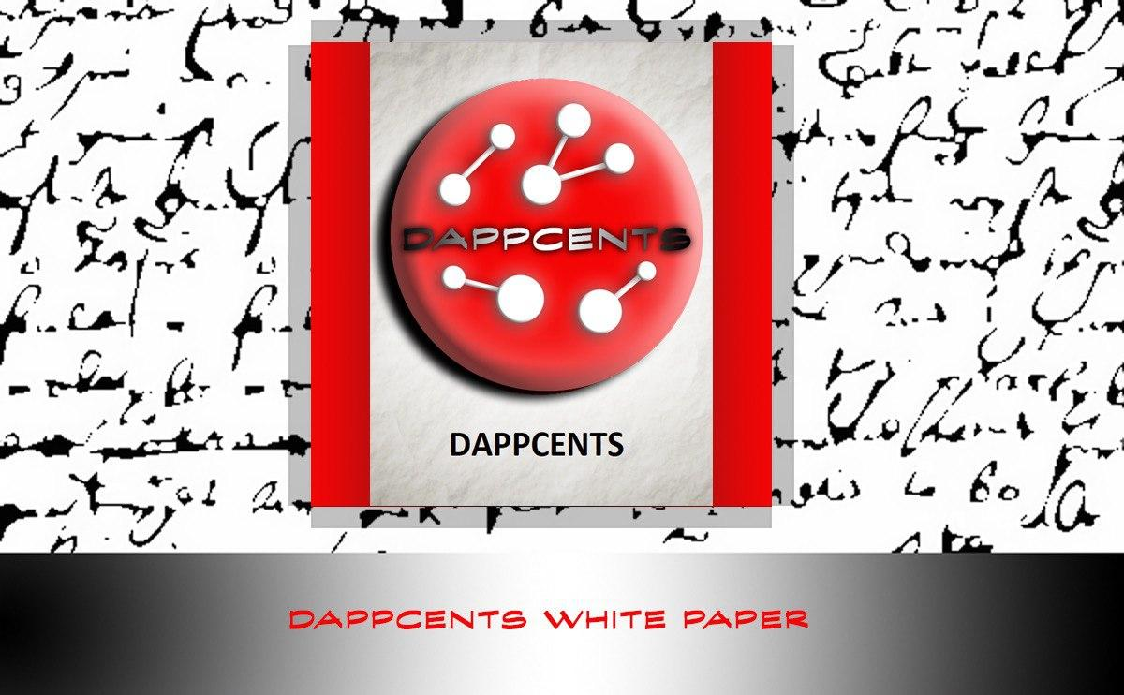

**INTRODUCTION**

We strive to help build communities for the best DAPPs (Decentralized Applications) in the crypto space using social media. Dappcentre platform consists of social media outlets such as: Telegram, Discord, Twitter, Facebook, Instagram, and most importantly our monetized YouTube channel. Dappcentre provides marketing services to crypto related businesses to help promote their products, while also building a community for their platforms. All profits made from monetization; referral commissions, & sponsorships will be distributed to all token holders.

**TOKEN**

DAPPCENTS (DPC) is a TRC-10 token on the TRON Blockchain. ICO (Initial Coin Offering) price is .25 TRX per token. All profits made from Dappcentre platform will be distributed to all DAPPCENTS token holders on a monthly basis. Dappcentre will live stream via Youtube on Dappcentre’s financial performance on a monthly basis, so there is full transparency on Dappcentre’s performance. All the profits made from monetization, referral commissions, & sponsorships will be converted into TRX and will be added to the dividend pool. Smart Contract will distribute the TRX in dividend pool to all DAPPCENTS holders by the 7th day each month. The more DAPPCENTS tokens you hold the more dividends you will receive in the pool.

Contract Address: TLnLRb3CGGtdEcucWn4MS6m5cpuyyFVaS4

Total Supply: 100,000,000

Circulating Supply: 89,472,966

Issue Date: 2020-08-06

Token ID: 1003129

**TOKENOMICS**

ICO (INITIAL COIN OFFERING) – 30 %

CONTENT CREATORS – 25%

DEVELOPMENT TEAM – 15%

BUYBACK PLAN – 10%

MARKETING – 10%

AIRDROP – 9.47%

RESERVED -0.52%

**SMART CONTRACT FUNCTIONALITY**

Dappcentre development team is working hard on building a smart contract functionality for DAPPCENTS, so all dividends can be distributed to every DAPPCENTS token holder autonomously. We realized that DAPPCENTS may need to be upgraded to a TRC-20 token. We will do a 1 for 1 swap from TRC-10 to a TRC-20 token if that ends up being the direction we go.

**ROADMAP**

|  |  |  |  |  |
| --- | --- | --- | --- | --- |
| **AUGUST**  **2020** | **SEPTEMBER 2020** | **OCTOBER**  **2020** | **NOVEMBER**  **2020** | **DECEMBER**  **2020** |
| * **DAPPCENTS TRC-10 TOKEN RELEASED**      * **WHITE PAPER RELEASE** * **PARTNERSHIPS** * **NEW SOCIAL MEDIA OUTLET** * **SMART CONTRACT BEING DEVELOPED** | * **FIRST MONTHLY BUSINESS REVIEW VIA LIVE STREAM** * **FIRST DIVIDENDS DISTRIBUTED TO TOKEN HOLDERS**      * **DAPPCENTS TRC-20 TOKEN BEING DEVELOPED (IF NEEDED)** * **MARKETING PLAN FOCUSING ON LEAD MEASURES** | * **TOKEN SWAP 1 FOR 1 IF TRC-20 TOKEN**   **NEEDED**   * **EXCHANGE LISTING ANNOUNCEMENT** * **IMPROVE CONTENT CREATION** * **WEBSITE UPGRADE** | * **HAVE OVER 5K SUBSCRIBERS ON YOUTUBE** * **SPECIAL PROMOTION ANNOUNCEMENT** * **ICO TOKEN SALE ENDS NOVEMBER 31ST** * **FIRST BUY BACK FOR TOKENS TO BE BURNED** | * **TOKEN LISTED ON EXCHANGE** * **COINGECKO LISTING** * **TOKEN LISTED ON CASINO WEBSITES** * **COMPLETE FIRST TOKEN BURN** * **FIRST ANNUAL EXECUTIVE MEETING VIA LIVE STREAM** |

**BUY BACK PLAN**

10 million DAPPCENTS (10% of the supply) will be held in the contract address TLnLRb3CGGtdEcucWn4MS6m5cpuyyFVaS4

All dividends distributed to this address will be used to buy back DAPPCENTS to stabilize the price.

All DAPPCENTS tokens bought back will be burned deflating the token supply and increase token value.

First token burn is planned to be completed by the end of 2020.

**TEAM**

**  
NERO**

**FOUNDER, CEO**

**RAIN_BOT**

**DEVELOPER, CTO**

**PANKUVIRAT**

**ADMIN, CMO**

**CAPSLADE**

**ADMIN, CAO**



**SUIZEN**

**ADMIN, CIO**

**ABHISAAR**

**ADVISOR, CXO**

**CHEVIX**

**CONTENT CREATOR, EDITOR**

**ANONYMOUS UNICORN**

**CONTENT CREATOR, EDITOR**

**PARTNERSHIPS**

**YOUTUBE MONETIZATION**

**CRYPTONEWSNET.COM**

**TRONWEEKLY.COM**

**GIGABET.COM**

**COSMOSGAME.IO**

**A.N. OVI**